Geolarm

Project Definition:
My app will be an alarm clock app with some extra functionality. Users will be able to create alarms that go off at particular times, particular days like any functional alarm, but will also be able to create alarms that only go off at a certain location, or don't go off at a certain location. The app will also be able to sync with a google calendar, to provide the user the option of automatically creating an alarm if an event in the calendar contains a user-specified word. The user will also be provided with the option of having their calendar opened up upon dismissing the alarm, or (time and available API provided..) a text to speech option to read off the events in their day.

User Story:
Erik has to travel a lot for his job and has a terrible time with organization. One his wife, Erika, has finished packing the last pair of socks into his suitcase she checks his schedule of events for each of the factory locations he's about to visit. She glances down and the schedule reads "Chicago IL - 10am conference room A; Manhattan NY - 11am Room 315; Bay Lake FL - 8am Disney World". Annoyed at the oversight of dates for each location, she sighs and concedes to downloading the GEOlarm application on Erik's android phone. While GEOlarm is downloading, she opens Erik's Google calendar and adds an event "thank your wife for saving your sorry butt" at 7pm every day he'll be gone. "Finished downloading GEOlarm" pops up on his phone just as she finishes.
She opens up the new application and adds a new alarm, titling it "Chicago", setting the location radius to 50 miles around Chicago ("who knows where those drunkos might end up..." she thinks), and telling the alarm to go off at 9:00am. She selects the option to have Erik's Google calendar open up his day when he dismisses the alarm, so as to make sure he sees the "thank your wife" event every day. Erika continues entering similar information for the next two days of Erik's trip. "Everything is all packed!" Erika calls to her husband. "Packed? Packed for what?" replies a confused Erik. After Erika calmly reminds him of his trip by slapping him with his schedule and boots him out of the house to the airport, immediately heading the the spa for the remainder of the week.
Erik stumbles off of his first flight in Manhattan, having thoroughly enjoyed the in flight beverage service. Seeing his coworkers (all in similar states of inebriation), he rushes over and they quickly call a cab to the bar to begin celebrating not having any work to do for the evening. Erik wakes up the next morning to a loud alarm going off in a hotel room. "Wha-? How did I get here? I didn't set this alarm? Why is it going off?" He hits the dismiss button before it gives him more of a headache than he already has. As soon as he hits the dismiss button his Google calendar is brought to the foreground. "Sweet magicky science this phone is awesome!" he says to himself while his calendar is loading. The only event scheduled for the day is "thank your wife for saving your sorry butt" scheduled for 7pm. making a mental note to do this he gets up for the day to go about his business. The rest of his trip continues in alternating stages of hungover days and drunken nights, but Erik remembers to call his wife every night over the trip. GEOlarm and Erika save Erik's career and possibly his marriage! Hooray!

Use Cases
a. Use Case List:

- Awake user creates new alarm
- Awake user deletes existing alarm
- Awake user edits existing alarm
- Sleepy user receives alarm notification
- Snooze alarm notification
- Dismiss alarm notification

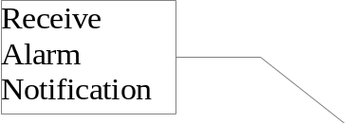
b. Use Case Diagram:
Awake
User
Sleepy
User

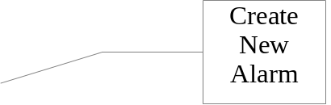

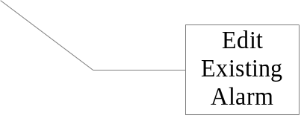
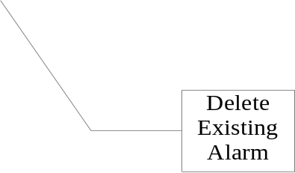
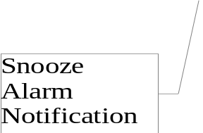

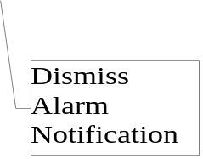

4c. Three Use Cases
Create New Alarm:
Title: As an awake user I want to create an alarm so that I may be woken up by it if in a particular location.
Primary Actor: Awake user
Stakeholders: The user wants to wake up at a particular time if in a particular location.
Preconditions: Users are using a device that has GPS functionality.
Postconditions: Sleepy user receives alarm notification at desired time
Success Scenario: 1. Awake user creates new alarm
2. Awake user sets alarm variables.
3. Awake user enables alarm.
Extensions: 2.1 Awake user can cancel the alarm creation.
Special Reqs: None.
Technology: GPS enabled device
Frequency: As frequently as the user wants to create new alarms.
Open Issues:

Receive Alarm Notification
Primary Actor: Sleepy user
Precondition: An alarm has been created and enabled.
Success Scenario: 1. Device plays alarm sound.
2. Device screen lights up.
3. User is given some form of notification with options to proceed.
Extensions: 3.1 User can select to snooze the alarm.
3.2 User can select to dismiss the alarm.
Issues:

Dismiss Alarm Notification
Primary Actor: Sleepy user
Success Scenario: 1. User has already received the alarm notification.
2. User gives input to dismiss rather than snooze received alarm notification.
3. Alarm is dismissed and will not activate until the next alarm.

Domain Classes:
Alarm - Has certain settings such as time, dates, on or off, and a name. Can be linked to a location.
Location - Represents a location in the world, has values such as center location and radius from that center.
Notification - The thing that is brought up / happens when an active alarm's time is reached. The user should be able to "dismiss" or "snooze" this notification.

Screen Specs:
